The various types of music brought with the people who began migrating to America in the early 1600s are considered to be the roots of bluegrass music---including dance music and ballads from Ireland, Scotland and England, as well as African American gospel music and blues.
The early Jamestown settlers began to spread out into the Carolinas, Tennessee, Kentucky and the Virginias, they composed new songs about day-to-day life experiences in the new land. Since most of these people lived in rural areas, the songs reflected life on the farm or in the hills and this type of music was called "mountain music" or "country music." The invention of the phonograph and the onset of the radio in the early 1900s brought this old-time music out of the rural Southern mountains to people all over the United States.

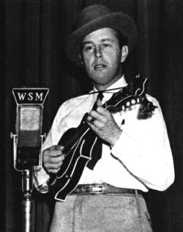
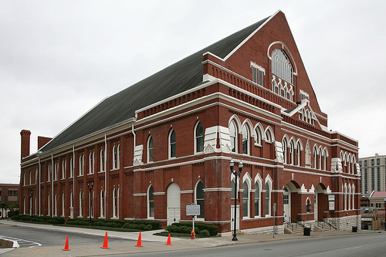
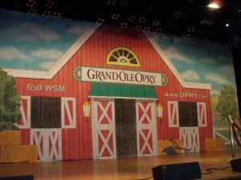
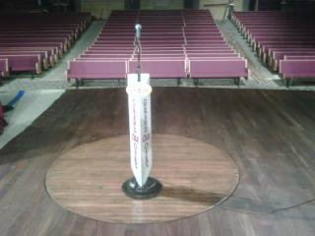
"Bill Monroe and the Blue Grass Boys" first appeared on the Grand Ole Opry in 1939!
The Grand Ole Opry is still going today!

The Monroe Brothers were one of the most popular duet teams of the 1920s and into the 1930s. Charlie played the guitar, Bill played the mandolin and they sang duets in harmony. When the brothers split up as a team in 1938, both went on to form their own bands. Since Bill was a native of Kentucky, the Bluegrass State, he decided to call his band "Bill Monroe and the Blue Grass Boys," and this band sound birthed a new form of music. “Bluegrass Music”
Bill Monroe became acknowledged as the "Father of Bluegrass Music.

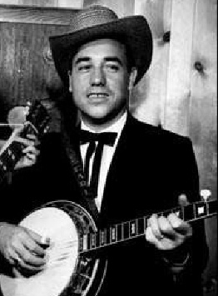
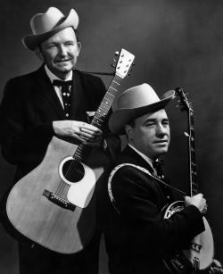
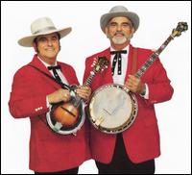
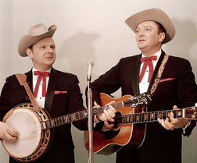
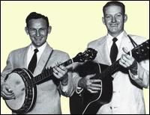
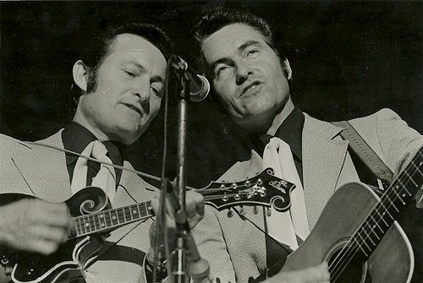
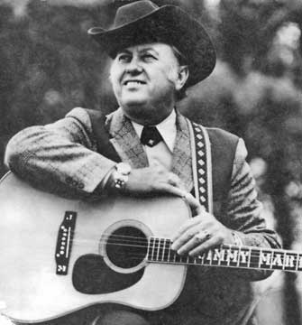
In 1945 Earl Scruggs, a 21 year old banjo player from North Carolina, joined Bill Monroe and the Bluegrass Boys. Scruggs played an innovative three-finger picking style on the banjo and has since come to be called simply, "Scruggs style" banjo.
From 1948-1969, Flatt & Scruggs and the Foggy Mountain Boys were a major force in introducing bluegrass music to America, with a tour sponsorship by Martha White Flour, as well as on a television show called The Beverly Hillbillies..
Other Legends in Bluegrass Music!
Known as the
“King Of Bluegrass”
In the 1960s, the concept of the "bluegrass festival" was first introduced. There are over thousands of bluegrass festivals world wide today.

